**HOLLYMOUNT NS**

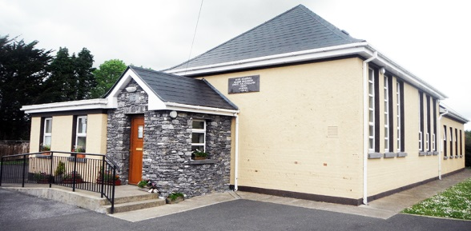

*Now Enrolling for Sept 2018*

Enrolment forms available and accepted through school office

064 7758269

www.hollymountns.ie

Follow us on Facebook