NOW ENROLLING for September 2021
Forms available by post or email from
8th February 2021
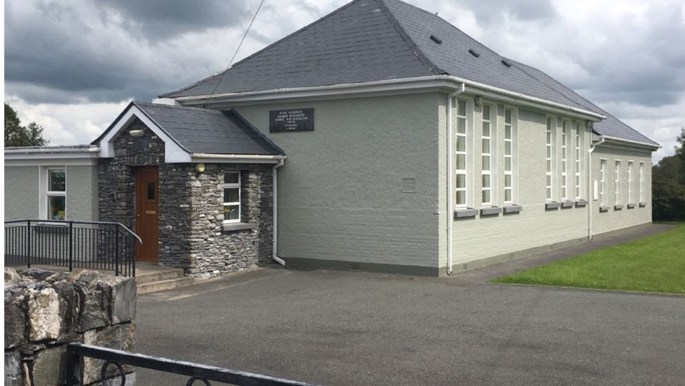
Fáilte is fiche romhaibh go léir.
Narodowa Szkola Hollymount
Zapisy uczniow na nowy rok szkolny
BEFORE YOU MAKE UP YOUR MIND
Ring 064-7758269 or email hollymountns@gmail.com
ALL ENQUIRIES WELCOME
Follow us on Facebook
https://www.facebook.com/HollymountNationalSchool/

