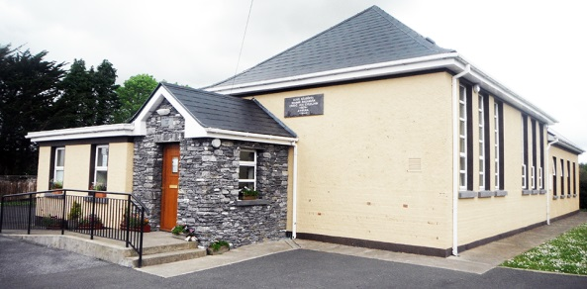
Hollymount National School
Hollymount, Rathmore, Co. Kerry.
Website: www.hollymountns.ie
Email: hollymountns@gmail.com
Tel: 064 7758269

Additional information of new pupils
Religious denomination: ________________________
Date and place of baptism: _____________________________________________________
Name and contact details of pre-school attended: ___________________________________
Any previous school attended: __________________________________________________
Name of family doctor: ___________________________ Phone no: ____________________
Arrangements to be made if child is ill in school: _____________________________________
Does any legal order under family law exist that the school should know about? ______________
(The school should be made aware of any court order which affects the child’s welfare and also the name of any person into whose custody the child should not be given)
Any other useful information: _________________________________________
List any problems the child may have in relation to health (allergies, epilepsy, asthma, sight, hearing, fainting, toilet training, inability to cope with buttons, laces etc.) or anything you deem necessary to bring to the schools attention.

*Please submit a copy of your child’s birth-cert which will be kept on file in the school*

