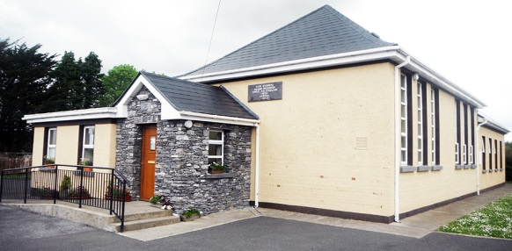
Hollymount National School
Hollymount, Rathmore, Co. Kerry.
Website: www.hollymountns.ie
Email: hollymountns@gmail.com
Tel: 064 7758269

Appendix to Enrolment Form

Hollymount NS is a catholic school whose work is underpinned by its Catholic ethos. Our aim is to provide a safe, happy learning environment where childrens emotional, psychological, physical and moral development is catered for in addition to their academic progress. The school promotes and expects from its pupils, a tolerance of different religious beliefs, and of those with no religions beliefs.
- I wish my child to be instructed in the Catholic Faith:
We/I understand that Hollymount NS is a Catholic School and wish our/my child to be taught in a catholic faith:
Yes ___ No ___

If yes, please sign here ___________________________

(You need continue no further)

- Respect for the beliefs of other:
- We/I understand that there is no compulsion on our/my child to take part in the religious education class in school.
- While we/I do not wish our/my child to be taught in a catholic faith, we/I respect the rights of other children to do so and we/I will ensure that our/my child do or say nothing that would undermine or compromise this basic right to religious expression.
Child’s name: _______________________ Class: ___________________
Signature of Parents/Guardians: ___________________________________________

