Hollymount N.S.
Rathmore
Co. Kerry
Phone: 064 7758269
Fax: 064 7758270

Email: hollymountns@gmail.com
Website: www.hollymountns.ie
Follow us on Facebook

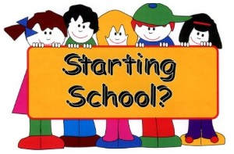

General Information for Parents of Infants starting in
Hollymount N.S.

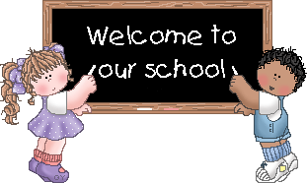
Starting school will be the first big change in the life of your child. Up to this your child has felt safe and secure with you in the home and how he/she is facing the wider world of the classroom and school. It is important that the transition from home to school is as smooth as possible.
Junior Infants is about settling in, relating to others, making friends, feeling happy and getting used to the routing of school. On the learning side, the emphasis is on getting children ready for learning by:
- Developing their oral language and expression.
- Improving their senses, especially seeing & hearing
- Developing physical co-ordination, especially of hands & fingers
- Extending their concentration span and getting them to listen attentively
- Learning through play.
- Co-operating with the Teacher and other children.
- Performing tasks by themselves.
- Working with others and sharing with them.
- Accepting the general order, which is necessary for the class to work well.

Before your child starts:
You should ensure that your child is as independent as possible – physically, emotionally and socially. If pupils can look after these areas they will feel secure and confident and settle in readily.

- Button and unbutton a coat and hang it up
- Use the toilet without help and manage pants buttons
- Your child should know how to flush the toilet & wash hands
- Use a tissue when necessary and cover mouth when coughing
- Be able to open & close school bags, lunch boxes & drinks containers
- Sit on a chair correctly at a table - encourage your child to work at a table when colouring etc.
- Be able to recognise their own belongings.
- Please label clothing, bags, lunchboxes etc as many of them look identical
- Share toys and play things with others and take turns
- Tidy up & put things away

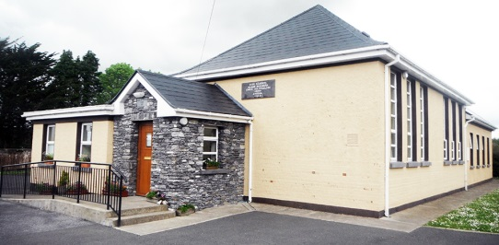
Hollymount National School
Hollymount, Rathmore, Co. Kerry.
Website: www.hollymountns.ie
Email: hollymountns@gmail.com
Tel: 064 7758269
‘The Big Day’
Your Childs first day at school is a day to remember for the rest of his/her life. You can help to make it a really happy one for him/her.
- Tell him/her about the school beforehand
- Don’t use school or Teacher as a threat. Though said light heartedly this can make some children very apprehensive.
- When the bell rings at 9.15am the children will line up at the back door
- Today Parents are welcome to bring their children into the class room until they are happily settled. The Teachers will gradually encourage the children to say goodbye to their Parents.
- Please ensure all books & copies are covered and clearly labelled with your Childs name on the front cover. All these books and copies will be collected on the first day of school and only taken home when needed for homework.
- A number of school books are rented from the school .
- Please be on time to collect your child. For the first few weeks your child will have a short day in school, finishing at 12noon for an initially settling in-period. Towards the end of September the children will have the full infant day (9.20am-2.00pm)

Start of day
- Children are not allowed in the yard before 9.15am. Children are not supervised before this time.
- When the bell rings at 9.15am, we would like you to say goodbye as they line up ready to go into class.

End of the day
- Be sure to collect your child on time.
- The children will be escorted out to the awaiting Parents. Children will not be allowed to leave until the teacher calls their names. The children will not be allowed to go unless there is a known adult waiting for them
- Please inform the class teacher or phone the school 064-7758269 if a different adult will be collecting your child.

Uniform/P.E. Clothing
Pupils must wear school uniforms at all times. Suitable footwear must be worn in the interest of safety. Our uniform consists of:
Girls | Boys
- Navy v-neck, dropped waist gym & navy cardigan  - Navy pants  - Blue blouse & navy tie  - Navy tights or white socks  P.E.  - Tracksuit  - Sneakers suitable for sports | - Navy pants & v-neck jumper  - Blue shirt & navy tie  P.E.  - Tracksuit  - Sneakers suitable for sports

Tracksuits are to be worn on P.E. days only weather permitted. P.E. days may vary over school year (Parents will be informed in advance).
Please label all your child’s clothes and belongings clearly and help them to identify their own belongings.
Uniforms are available in local shops. Plain tracksuit jumpers/bottoms and polo t-shirts can be bought in many department stores i.e.: The Washbasket Rathmore, Dunnes Stores, Marks & Spencers, Tesco, Heatons etc.
Homework
- Please check your child’s homework journal every day for homework and important notes.
- Set aside a quiet regular time.
- The child should be sitting comfortably at a table.
- Encourage your child to keep books and copies clean & tidy.
- Encourage your child to always do their best.
- Please check all homework and sign homework journal every night.

Important Notes:
Children often forget or relay messages incorrectly, so please check your childs bag and homework journal each night for notes. Please ensure any reply slips are returned to school promptly. Updates are regularly posted on our school website and Facebook page.

Parent/Teacher Meetings

- Parent/Teacher meetings will be held during the school year. It is important that you attend these in order to keep in touch with your Childs progress.
- If your child is experiencing any difficulties with any aspect of school life, either classroom or playground please talk to your child’s Teacher. Please make an appointment through the school secretary.

Packed lunches
Your child will have a short day for the first few weeks so a small snack is sufficient.
Lunch is an important meal for school going children. We operate a ‘Healthy Eating Policy’ and ask you to encourage a healthy lunch right from the start (fruit, sandwiches, yogurts (with spoon packed) & a drink). Please give your child food he/she can easily open and manage to eat. One small treat on Fridays – no crisps please.

Lunch Times
Break: 11.00am - 11.10am
Lunch: 12.30pm – 1.00pm
When weather permits, children will go outside to play in the school yard. Children are supervised by a teacher during each break

Health
IF you have any concerns about your Childs health or if he/she has a medical condition that we should be aware of please let us know before he/she starts school. We can then discuss the matter with you and be fully aware of and prepared for any possible difficulties.
Please remind teacher in September if your child has any health problems we should know about-eyesight, hearing, asthma, allergies etc. Please make the class teacher aware of any inhalers/ epipens that will need to be kept in the school.
Please inform the teacher if something of emotional significance has occurred in your child’s life (moving house, death, separation, accident, new baby etc.) as these can also have an effect on your child at school.
If your child has a bout of sickness please keep him/her off school for 24 hours after symptoms have stopped. This type of illness can spread so quickly easily among children and staff!

Social Skills
Social skills are very important. We encourage good manners at all times, please/thank you, addressing teachers properly, being courteous to fellow students and teachers. Rough behaviour is totally discouraged in the playground and the classroom.
Do’s | Don’ts
- Do be kind and helpful  - Do be gentle  - Do listen  - Do work hard  - Do be honest  - Do look after property | - Don’t hurt people’s feelings  - Don’t hurt anyone  - Don’t interrupt  - Don’t waste your or other people’s time  - Don’t cover up the truth  - Don’t waste or damage things

Respectful Environment
This school is a respectful happy place. Each child’s ethnic origin and religion is respected. It is expected that all children will also respect other children in the school.
It is important that your childs ability to talk is as advanced as possible. It is through speech that he/she communicates his/her thoughts and feelings, his/her needs and desires, curiosity and wonder. A child needs to be able to follow instruction and understand what teachers are saying, as well as being able to communicate well with the teachers and other students.

Junior Infant Subjects
Engish:  Oral  Phonics  Reading  Writing | Gaelige: | Maths:
Religion: | S.E.S.E:  History  Geography  Science | P.E.
S.P.H.E:  Social, Personal, Health Education | Arts:  Visual Art  Drama  Music

If you have any other questions or concerns, please do not hesitate to ask the Teacher or School Principal

