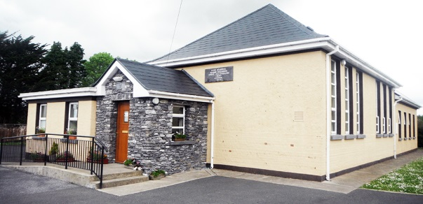
Hollymount National School
Hollymount, Rathmore, Co. Kerry.
Website: www.hollymountns.ie
Email: hollymountns@gmail.com
Tel: 064 7758269

Hollymount NS School Enrolment

Dear Parents/ Guardians,
We extend a warm welcome to you and your child as they begin school. In your enrolment pack you should receive:
- An application form.
- Contact numbers form (in case of emergency).
- Parental consent forms.
- Appendix to Enrolment form (Religious Education).
- Homework Policy is available to view online or request a hard copy from the school office.
- Code of Behaviour policy is available to view online or request a hard copy from the school office.
- Information about the school.
- Enrolment information form.
Please return completed forms along with a copy of your child’s birth-cert to the school.
Please read all of the accompanying documents carefully.
If you have any questions or queries, please do not hesitate to contact the school.
Mise le meas,
______________
Caroline Ruiséal
Principal

