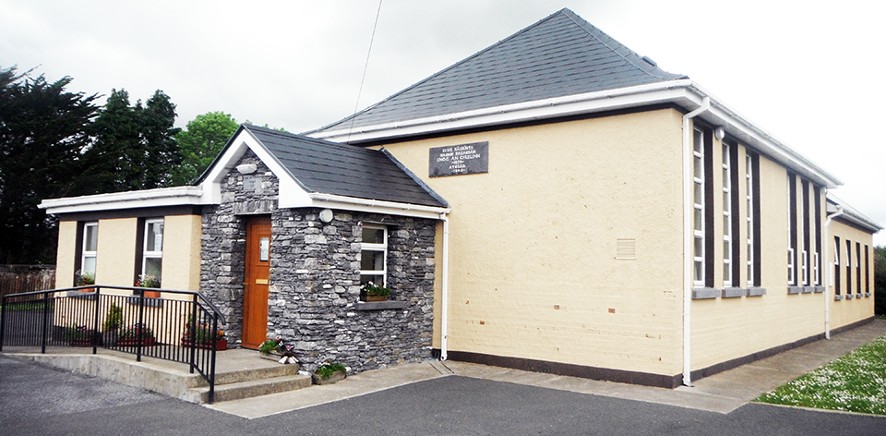

School Information

- The school is under the patronage of the Bishop of Kerry.
- The denominational character of the school is catholic.
- The teaching staff is comprised of two class teachers, SNA and support teachers.
- The full range of classes is taught in this school and classes are of mixed gender.
- Classes start at 9.10 am and finish at 3.00 pm. Classes for infants finish at 2.00 pm. There are two breaks in the school day

11.00 am – 11.10 am
12.30 pm – 1.00 pm

- The standardised school year as set down by the Department of Education and skills governs the length of school terms and holidays. From time to time there may be exceptional school closures, of which you will be notified.
- School Uniform:
Girls – A navy gymslip/pinafore, a blue blouse, navy tie and a navy cardigan
Boys – A navy pants, a blue shirt, a navy tie and a navy jumper
Shoes should be safe for walking and playing. (No platforms or
roller blade/skate allowed).
- All absences should be explained by a note (not in journal).

